**Comstock Park**

**Fall Classic Run 2015**

**A HUGE *THANK YOU* TO OUR SPONSORS!!**

**Presenting Sponsor: Hosting Sponsor:**  
• [**United Bank**](http://www.unitedbankofmichigan.com/)* **Vitale’s of Comstock Park**

**Gold Sponsors: Silver Sponsors:**  
* [**Comprehensive Physical Therapy Center**](http://www.comprehensivephysicaltherapy.com/3-mile-staff/#content-tab-1-0-tab)* [**Dooge Veneers**](http://www.doogeveneers.com/) **\*** [**Presto Print Inc.**](http://www.prestoprintinc.com/) **\*** [**Dubric**](http://www.dubric.com/) **\* Nucraft** * [**KSS Enterprises**](http://kssenterprises.com/)

**\* Schaafsma Heating & Cooling**

**\*** [**The Runnery**](http://therunnery.com/)

**\*** [**Scott Lake Country Club**](http://www.scottlake.com/)

**Supporting Sponsors:**   
* [**Ed Hood Real Estate**](http://www.midwestagents.com/)

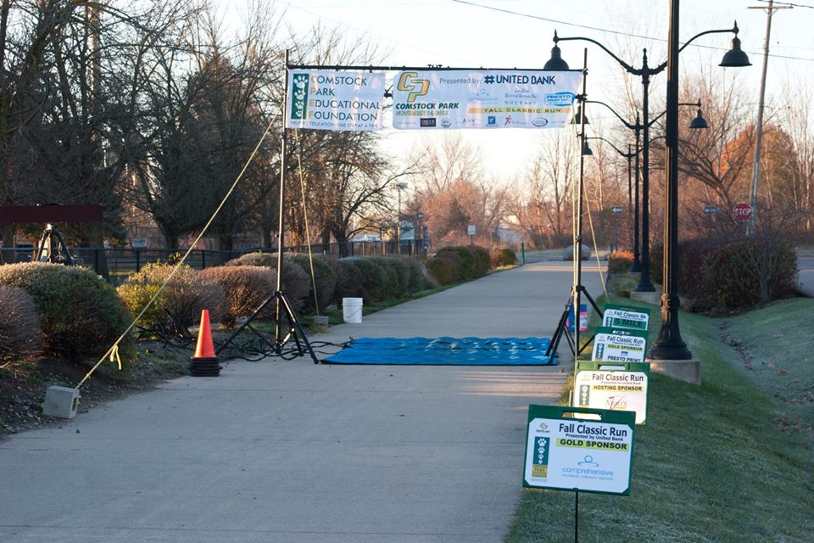

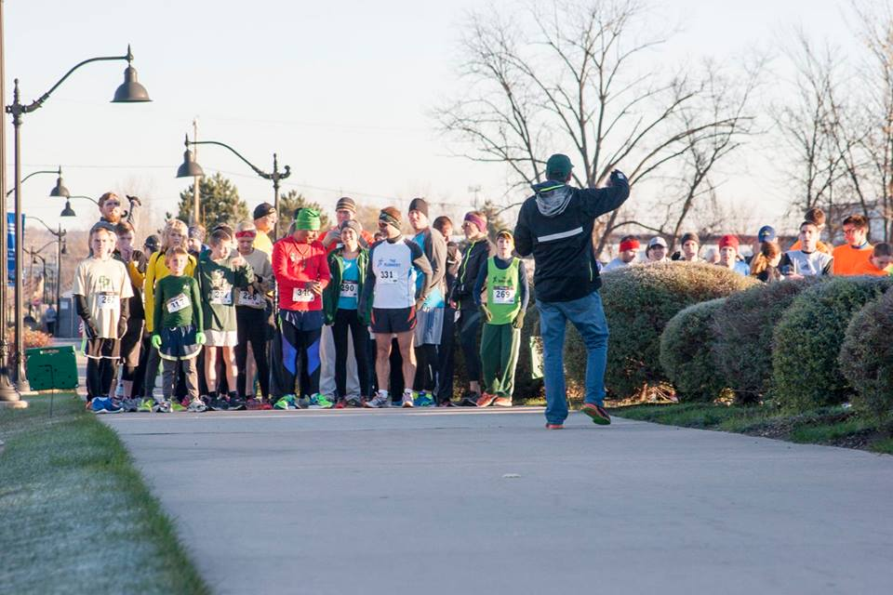

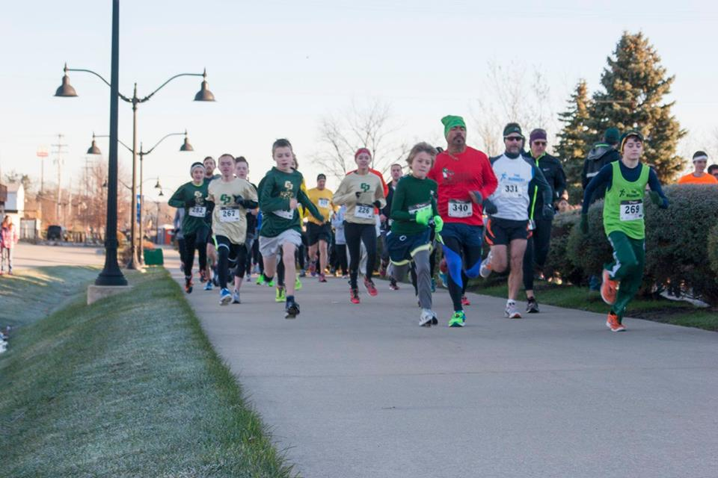

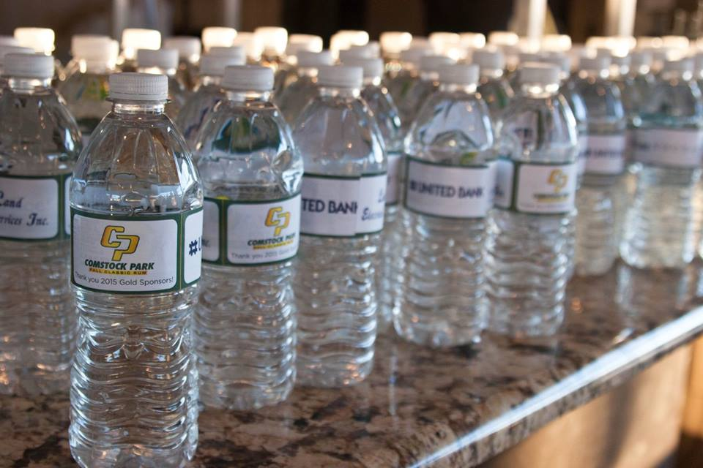

Benefiting Organizations:  
• [Comstock Park Educational Foundation](http://www.cpef.us/)  
• Comstock Park High School’s Track & Cross Country programs